UI Prototype

# Project Name

Applied Language Research

**Prepared by**

Applied Language Team

# Date

1 November 2020



# 1. Overview

User interface prototypes are preliminary representations of the future website’s design, and are essential to mock-up before the creation of a product for a multitude of reasons. Firstly, prototypes are much cheaper to create than the final product. A team can identify conflicts to fix or changes to be made early in the development process so that time is not wasted going back and making those changes during implementation. Changing a prototype is a quick process that doesn’t require the delicacy and involvement that is required of making changes to a live product. Additionally, prototyping allows a team to gather early feedback from user groups. There are three different types of prototypes, low, medium, and high fidelity prototypes. Low-fidelity are quick mock-ups that have the lowest cost for making changes, at the expense of a less clear representation of the final product. Medium fidelity prototypes are much more involved and may include some functionality, with high-fidelity being close to the final product.

# 2. Low-Fidelity Prototypes

Low-fidelity prototypes are generally hand-drawn, simple mock-ups of an interface which can be arranged as a storyboard to show how a user might utilize the website. They show the different features of the website that users require but without the functionality. They are quick and easy for a team to create, saving the team from spending time making a prototype when that time could be utilized elsewhere.

## A. Use-Case Scenarios

**Scenario I:** You are a linguistics researcher who would like to register a new account so you can view statistics on commonly mispronounced words and download them for further research.

Tasks (Functional Requirements): R.H.3, R.H.4, R.H.6, R.H.7, R.H.8, R.M.2, A.M.1

1. You navigate to the ‘Home’ page.
2. Navigate to the ‘Account Creation’ page
   1. You select the ‘Create Account ‘ button on the ‘Login’ page.
   2. You fill in your account details in the text fields and click the ‘Submit’ button. (R.H.6)
3. Account confirmation
   1. You are taken to the ‘Account Confirmation’ page where you are notified to to wait 24-48 hours for the admin to approve your account request. (A.M.1)
   2. You receive a confirmation email so that you can browse the website in the meantime. (R.H.8)
   3. After your account has been approved by an administrator, you proceed to the ‘Login’ page, enter your email address and password, and click ‘Login’. (R.H.7)
4. You navigate to the ‘Statistics’ page.
   1. You set filters for the data, selecting the Blackfoot Language, and entering specific words to display. (R.M.2)
   2. A graph displays with the words’ average ratings. (R.H.4)
   3. You decide to download all the files in a CSV format. (R.H.3)

**Scenario II:** You have been trying to practice your Blackfoot pronunciations and have heard from a friend about a brand new website connecting learners with feedback from Native Language Speakers. Jumping at the opportunity, you register a new account with the website and confirm your account. You login.

Tasks (Functional Requirements): L.H.4, L.H.5, L.H.6

1. Navigates to the Home page
2. Registers a new account
   1. Selects the ‘Create Account’ button on the Login screen.
   2. Fills in account details in the text fields, and presses submit. (L.H.4)
3. Confirms account
   1. You are taken to the ‘Email Confirmation’ page where you are notified to check your email for a confirmation link.
   2. You click on the link in the email and are taken to a notification page informing you that your account has been confirmed and you may now proceed to login. (L.H.6)
4. Login
   1. Having successfully registered and confirmed your account, you proceed to the ‘Login’ page and enter your email address and password, and click the ‘Login’ button. (L.H.5)

**Scenario III**: You are a language learner or a researcher, who is already logged in to the website, and want to upload an audio file of a word to the system for the pronunciation of this word to be rated by a Native language speaker.

Tasks (Functional Requirements): R.H.1, R.M.1, L.H.1, L.H.2, L.M.1, L.M.2

1. You click on the ‘Upload Audio’ tab to navigate to the ‘Upload Audio’ page.
2. Uploading audio
   1. On the ‘Upload Audio’ page, you select the audio file on your computer. (L.H.1)(R.H.1)
   2. You decide that you want to record a new audio clip instead. (L.H.1)
   3. You playback your audio clip to ensure that it sounds correct. (L.M.1)
   4. Upload the full audio file.
3. You trim your audio into smaller audio clips by word.
   1. You select the first word and save that trim with a text description. (L.H.2)
   2. You continue to step until you have trimmed each word and added text descriptions. (R.M.1)(L.M.2)
4. Your saved trimmed audios are now available to be rated.

**Scenario IV:** You receive an email with a unique link to the rating page generated from Scenario III. You then send this link to a Native Language Speaker, who rates the audio pronunciation, which sends another email to you on completion.

Tasks (Functional Requirements): R.H.5, R.H.9, N.H.1, N.H.2, N.M.1

1. You get sent an email with a unique link to the rating page and then you send it to the Native Language Speaker. (R.H.5)
2. Rating
   1. Native Language Speakers follows the emailed link to a page that bypasses login requirements so they can leave a rating. (N.H.2)
   2. Native Language Speaker listens to the uploaded audio recording then leaves a rating between 1 and 7. (N.H.1)
   3. Native Language Speaker optionally decides to leave a written comment about the learner’s pronunciation. (N.M.1)
3. You then get sent an email verifying that the Native Language Speaker completed the rating. (R.H.9)

**Scenario V:** You have been using the Applied Language Research website as a Language Learner for many weeks, and, after logging in, have decided to review your past audio recordings to take note of your progress.

Tasks (Functional Requirements): L.H.3, L.M.1

1. Navigate to the ‘View Audio’ page.
2. Play back your audio file to remember what you said. (L.M.1)
3. Scroll down to the feedback section
   1. You see your average rating and all the comments. (L.H.3)
   2. Review your pronunciation and improve

## B. Functional Requirements Reference

|  |  |  |  |
| --- | --- | --- | --- |
| **Scenario/Task** | **Functional Req** | **Priority** | **Figure** |
| I/2b | R.H.6 | High | 2 (Account Creation) |
| I/3a | A.M.1 | Medium | 3 (Confirmation) |
| 1/3b | R.H.8 | High | 3 (Confirmation) |
| I/3c | R.H.7 | High | 4 (Login) |
| I/4a | R.M.2 | Medium | 5 (Statistics) |
| I/4b | R.H.4 | High | 5 (Statistics) |
| I/4c | R.H.3 | High | 5 (Statistics) |
| II/2b | L.H.4 | High | 2 (Account Creation) |
| II/3b | L.H.6 | High | 3 (Confirmation) |
| II/4a | L.H.5 | High | 4 (Login) |
| III/2a&b | L.H.1 | High | 7 (Upload Audio) |
| III/2a | R.H.1 | High | 7 (Upload Audio) |
| III/2c | L.M.1 | Medium | 7 (Upload Audio) |
| III/3a | L.H.2 | High | 9 (Trim Audio) |
| III/3b | L.M.2 | Medium | 9 (Trim Audio) |
| III/3b | R.M.1 | Medium | 9 (Trim Audio) |
| IV/1 | R.H.5 | High | See Section E |
| IV/2a | N.H.2 | High | 6 (Rating) |
| IV/2b | N.H.1 | High | 6 (Rating) |
| IV/2c | N.M.1 | Medium | 6 (Rating) |
| IV/3 | R.H.9 | High | See Section E |
| V/2 | L.M.1 | Medium | 8 (View Audio) |
| V/3a | L.H.3 | High | 8 (View Audio) |
|  | R.H.2 | High | See Section E |
|  | R.H.6 | High | See Section E |
|  | A.H.1 | High | See Section E |
|  | A.H.2 | High | See Section E |
|  | A.H.3 | High | See Section E |

## C. Sketches

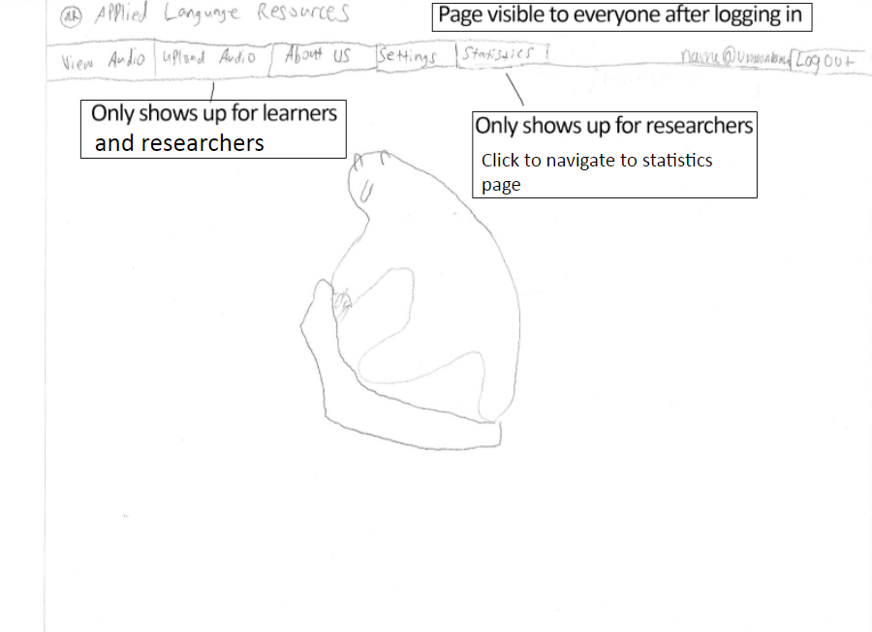

Figure 1: Home Page Post-Login

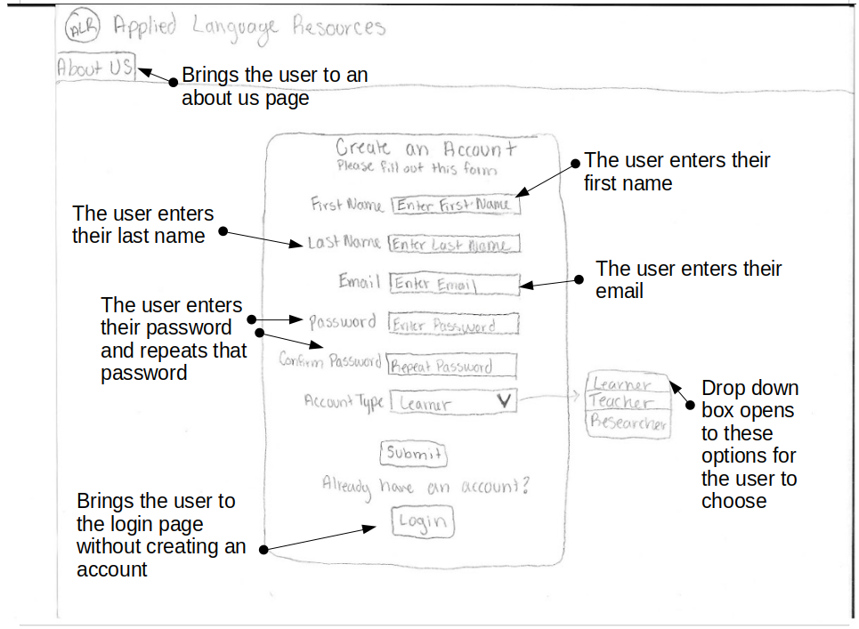

Figure 2: Account Creation Page

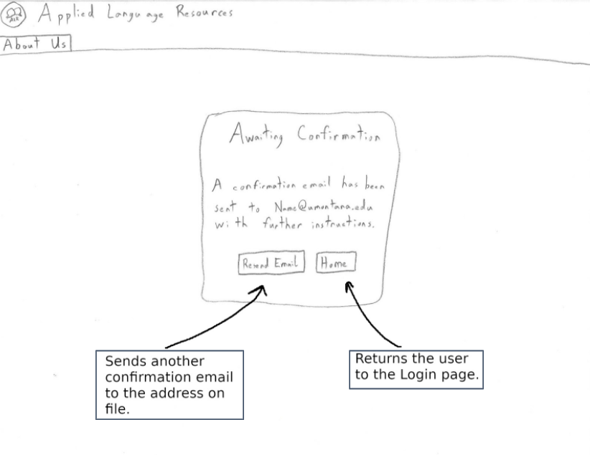

Figure 3: Confirmation Page

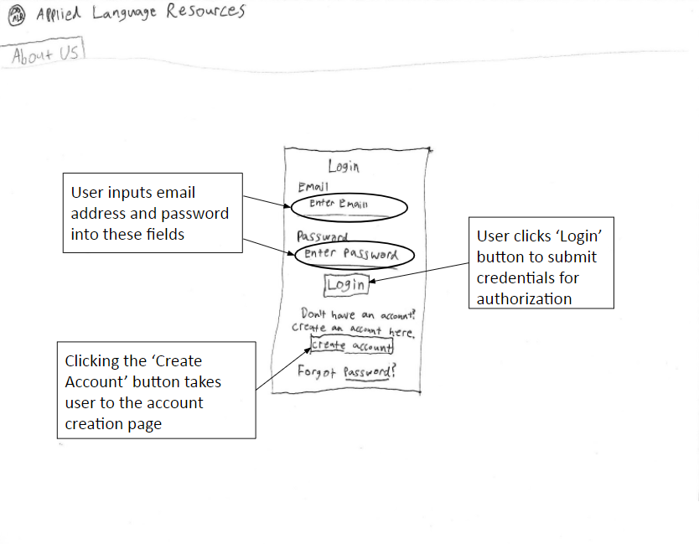

Figure 4: Login Page

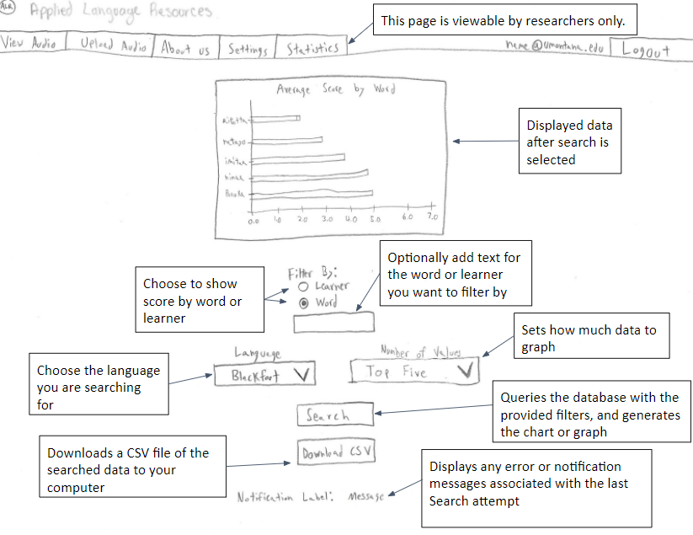

Figure 5: Statistics Page

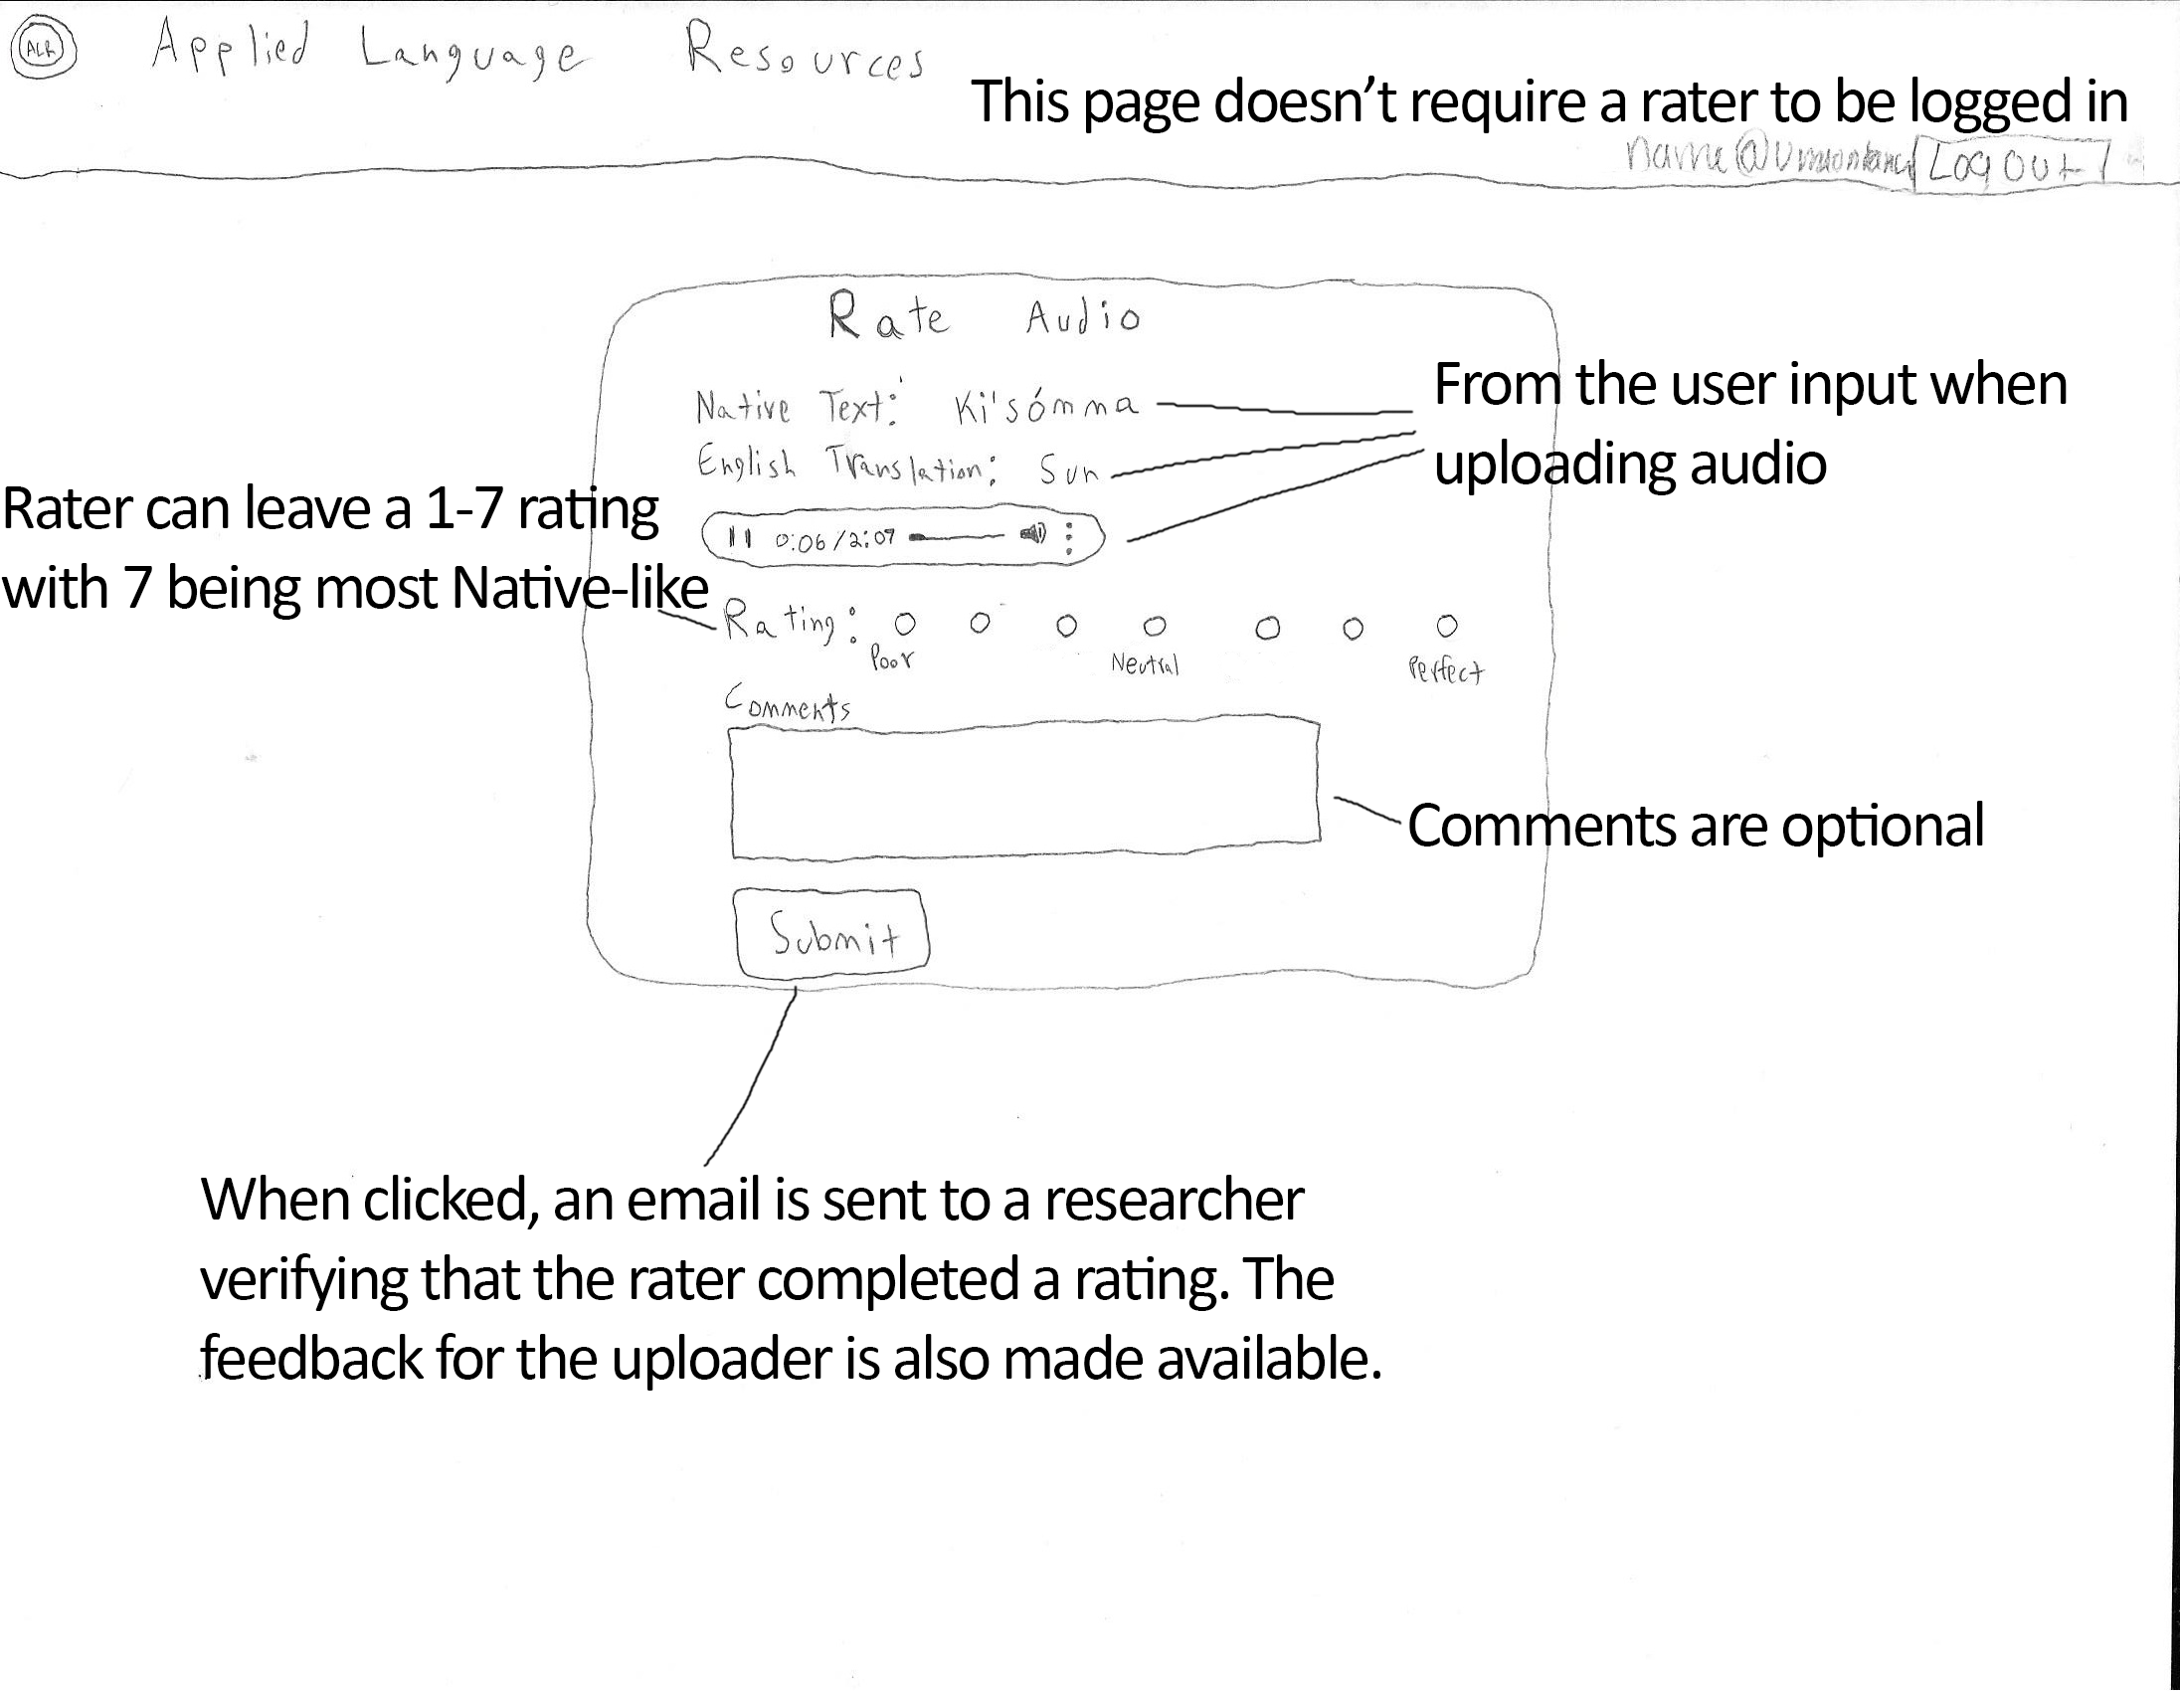

Figure 6: Rate Audio Page

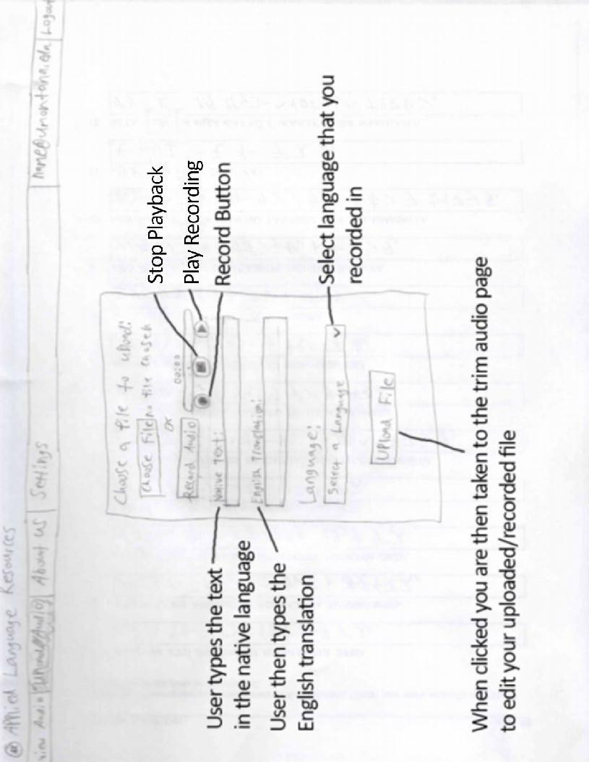Figure 7: Upload Audio Page

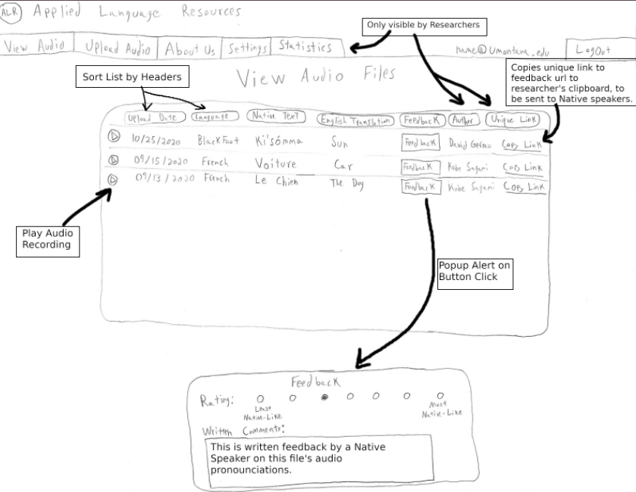

Figure 8: View Audio Page

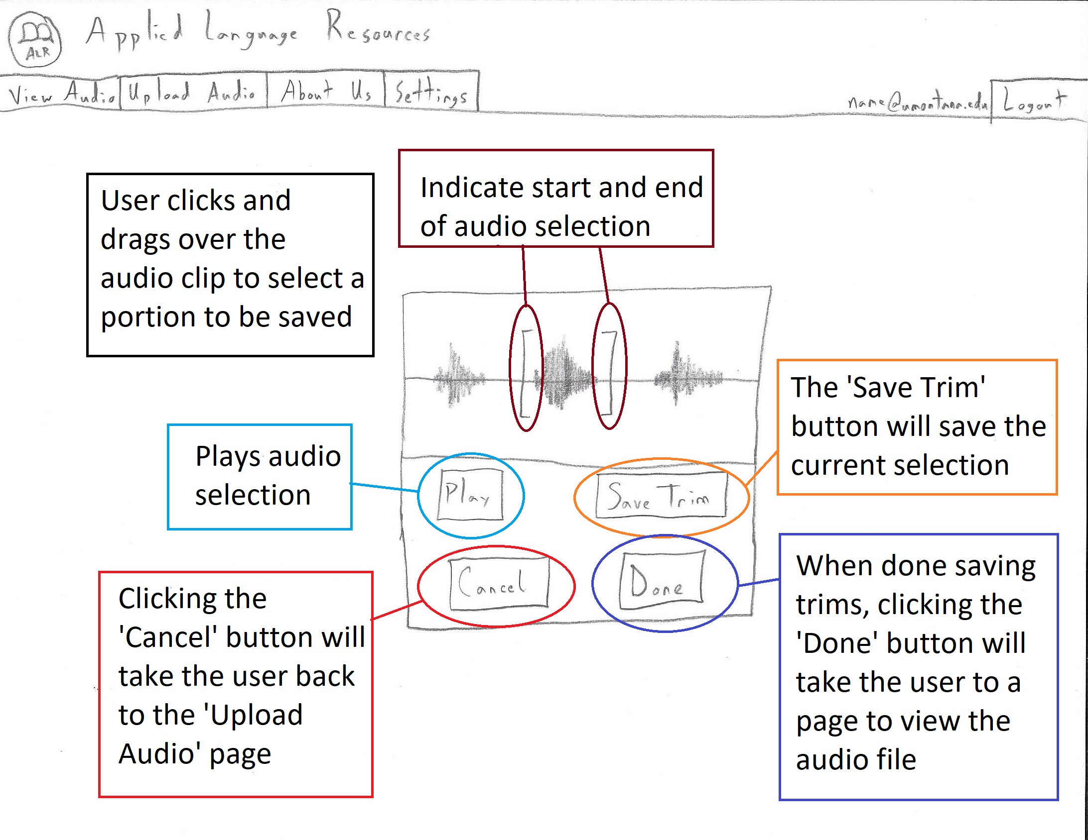

Figure 9: Trim Audio Page

## D. Storyboards

**Scenario I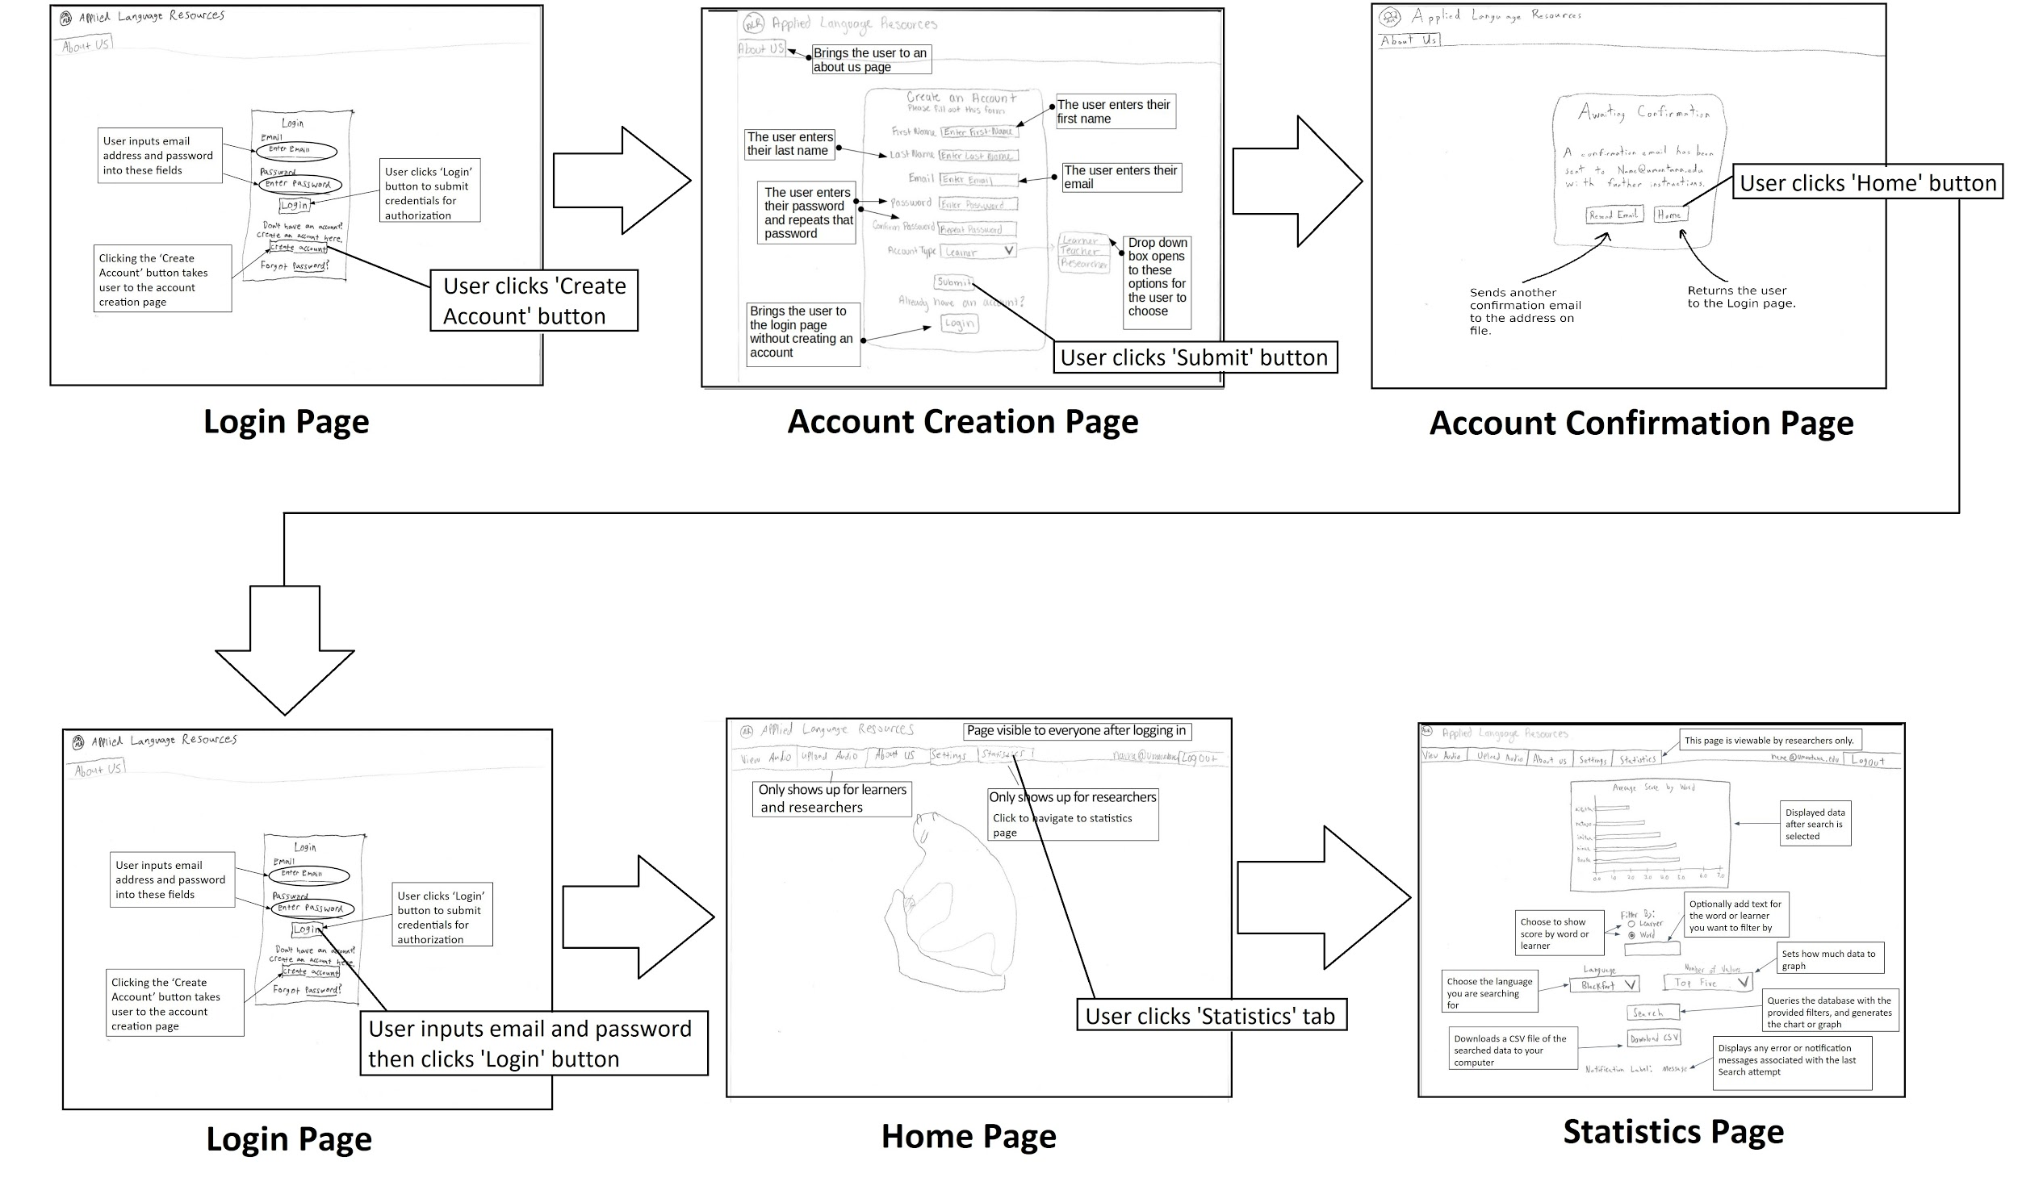Scenario II**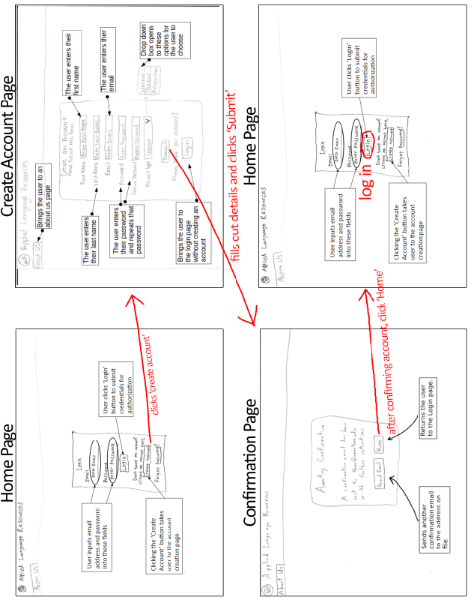

**Scenario III**

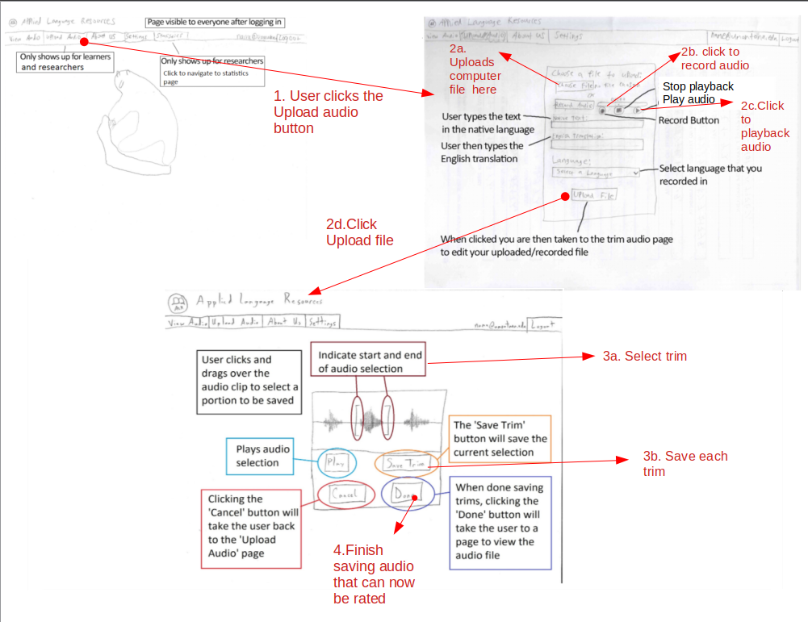

**Scenario IV**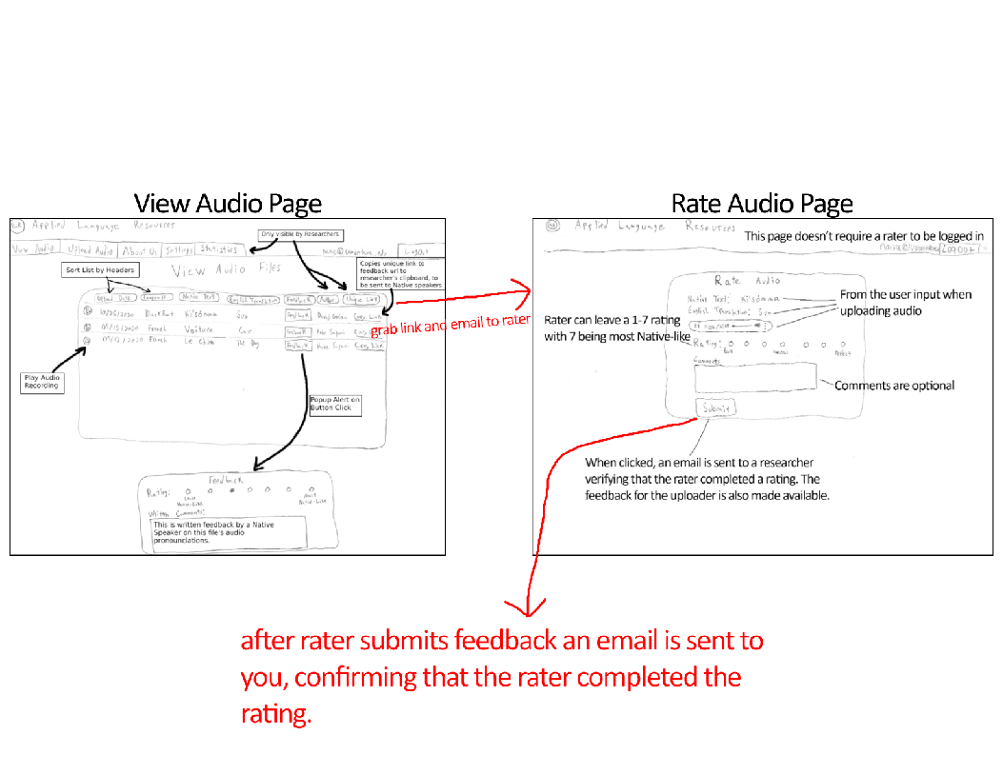

**Scenario V**

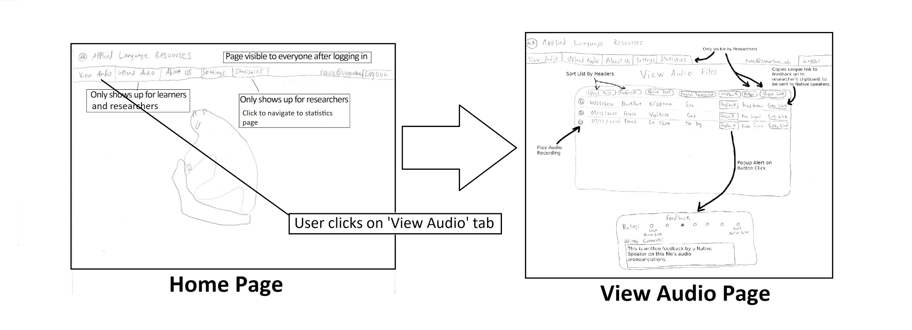

## E. Omissions

*R.H.2: Researchers should be able to upload previously gathered data including excel sheets, audio files, acoustic measurements, and word ratings.*

This requirement was not included in any scenario because this action will rarely happen (possibly only once at the beginning of use), and this functionality will not be present on the website itself. This functionality is for directly importing data into the database and thus will likely use an external offline script.

*R.H.5: Researchers should be able to provide a unique link to a Native language speaker that allows the speaker to rate an audio clip without logging in to the website. This unique link is meant to be used by only one Native language speaker.*

This requirement is described in Scenario IV/1. However, it does not have a sketch because it is a link that will be sent from the Researcher’s email to the Native Speaker’s email and not through a page on the website. This unique link brings the user to the rate audio page.

*R.H.9: Researchers should be sent a verification email when a Native Language Speaker completes a rating.*

This is included in Scenario IV/3. Just as in the above case with R.H.5, after the Native speaker has submitted the rating, an auto-generated email will be sent automatically to the researcher’s email. This will not be a page on the site requiring user input.

*A.H.1: Administrators should be able to add and remove users from the other user groups.*

This administrative requirement was not included in any scenario because it is conducted through the database, and not through an interface on the website.

*A.H.2: Administrators should be able to backup and restore all of the audio files stored on the web server and data stored in the database*

This administrative requirement was not included in any scenarios because it is conducted through the web server via an FTP client or shell script, not through an interface on the website.

*A.H.3: Administrators should be able to perform all functions that any other user type can perform (researchers, language learners, Native language speakers, and teachers)*

This requirement was not included in the above scenarios due to it, by its nature, being an exact duplicate of every scenario and requirement.

# 3. In-class presentation

During and after our in-class presentation, we received feedback across many topics largely centered around the statistics page filtering and the navigation buttons at the top of the website. These recommendations are summarized in the following sections.

**Statistics Page Data-Filtering Feedback**

We received feedback from our peers on the statistics page on a number of topics related to the filtering of data. In its current state, the paper prototype has a limited number of filters that allow the researcher to view average ratings by words or learners and restrict the data output to just a single word or learner or the top or bottom ten rated words.

User feedback from the class presentation suggested that we include additional filters on this page, including an add word/learner button that would allow the researcher to add multiple words or learners to an expanding list. We believe this is a great idea and will update the existing prototype to have a pair of lists, one for words and one for learners, where the researcher can add words and learners. This has the added benefit of verifying that the word or learner exists in the database with each button click to add that word or learner.

We have also decided to expand the possible limits placeable on the data to include start and end dates for the ratings being considered.

**Navigation Bar Feedback**

The navigation buttons at the top received several critiques from the class, ranging from the ideal location of two of the general page buttons to the ‘View Audio’ page button’s naming. It was raised by the course instructor that ‘View Audio’ is a bit of an oxymoron and suggested that it be changed to ‘Review Audio.’ Our student peers also suggested that we move the ‘About Us’ and ‘Settings’ buttons out of the main navigation section, as these pages are not part of the main functions of the website. As a group, we have decided to turn the user’s email address at the top right side of the navigation bar into a dropdown, with the renamed ‘Settings’ (now ‘Account’), ‘About Us’, and ‘Logout’ buttons.

The final suggestion we received was to include a way to display the user’s type in the navigation bar. However, this is made difficult with the possibility for a user to have multiple types. Ultimately, we have decided to stick this information on the ‘Account’ page.

